Boston Massacre Art Analysis
Name: ____________________________________Pd ____
Art Analysis
1. Take five minutes to independently look over each of the paintings from the Boston Massacre. On this sheet, jot down any notes, remarks or questions you might have about each artist’s depiction of this event.

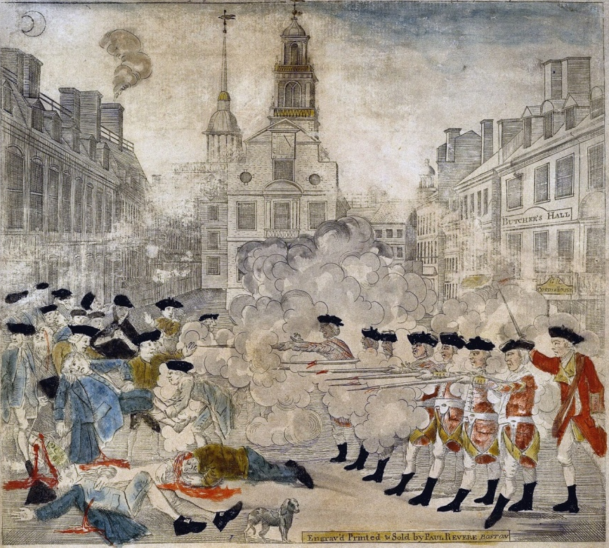
Painting A: "The Boston Massacre" - Paul Revere, 1770 courtesy of the Gilder Lehrman Institute

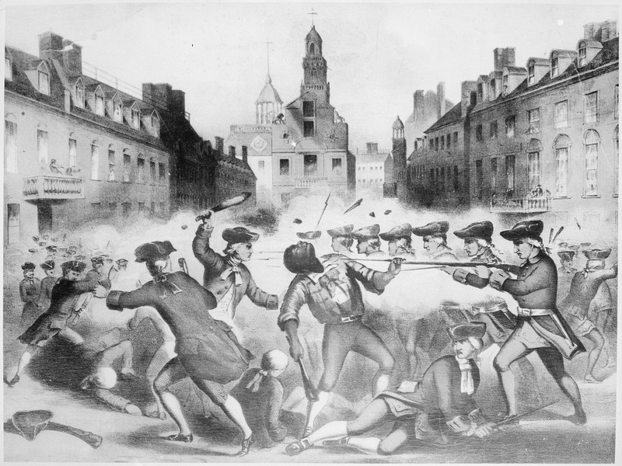

Painting B: chromolithograph by John H. Bufford based on a drawing by William L. Champney (1856),

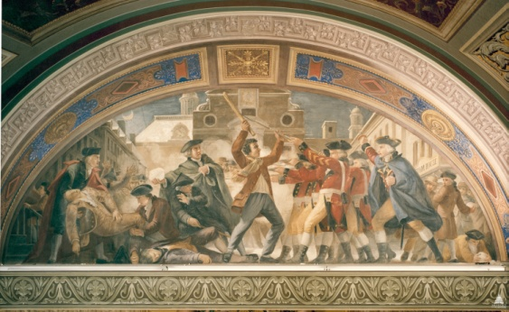
Painting C: Constantin Brumidi Fresco from the US Capitol, 1871

Painting D: "The Boston Massacre" - Artist Unknown, appeared in 'Centennial Album', 1873

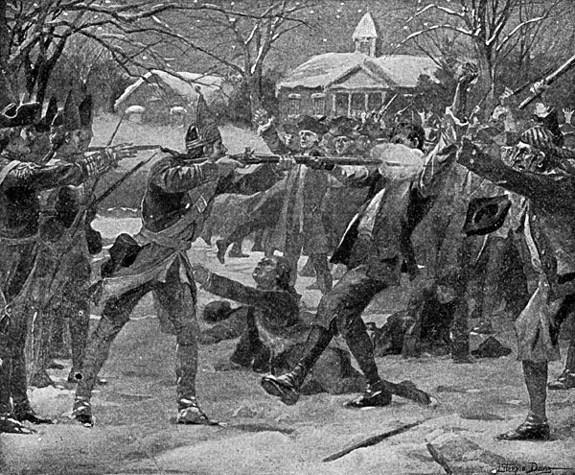
Painting E: Artist and date unknown

Work with your small group to answer the questions on this side of the page.

Understanding the Event
2. Provide a brief summary of the events of the Boston Massacre.

Group Questions
3. In examining all five of the paintings, do you have a strong sense of time or season of this event? Explain.

4. Of the five paintings, which two paintings do you feel are most similar? Explain what you feel makes them similar.

5. Which of these five depictions do you feel shows the Patriots in the most favorable light? What makes you say this?

6. Do any of these depictions show the British soldiers as more aggressive than another painting? In what way did the artist show their aggression?

7. How did the artists portray the central figure in paintings B and D? What might account for the differences?

8. If you were writing an entry for an illustrated encyclopedia. Which of the five paintings would you choose for your entry and why? (presumably, you are picking the one you feel is the most correct.)

