Despite Attucks’ prominent placement in 18th century prints, he goes missing in several popular prints from the nineteenth and twentieth centuries. The Alonzo Chappel image below, produced for Heppenheimer and Maurer’s popular Centennial Album in 1873, appears to be loosely based on a Bufford chromolithograph, but a white man has replaced Attucks in the central position.
"The Boston Massacre" - Alonzo Chappel, appeared in 'Centennial Album', 1873

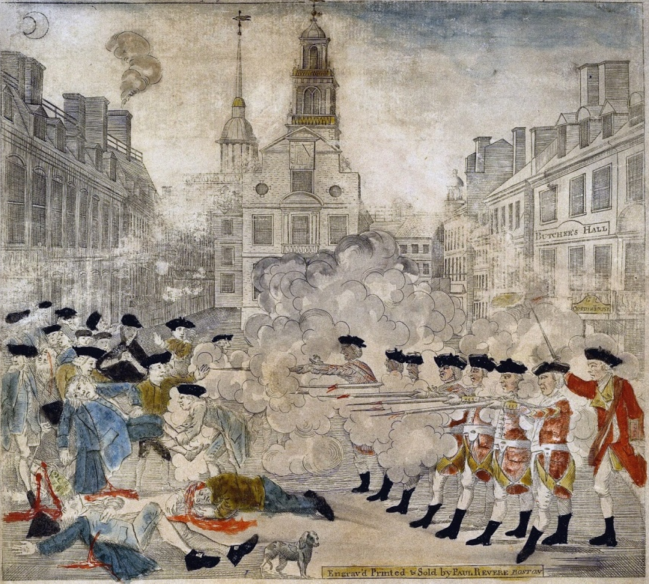
"The Boston Massacre" - Paul Revere, 1770 courtesy of the Gilder Lehrman Institute

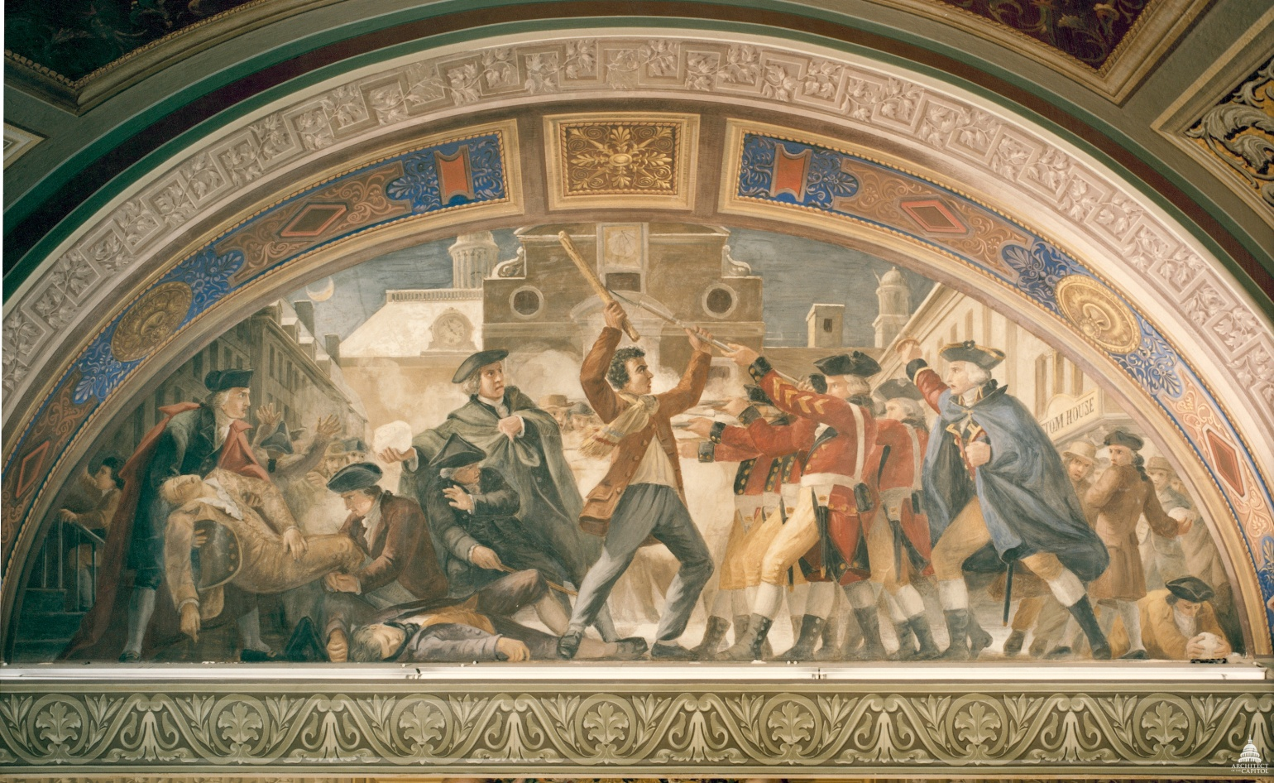
Constantino Brumidi Fresco 1871 Room S-128 U.S. Capitol

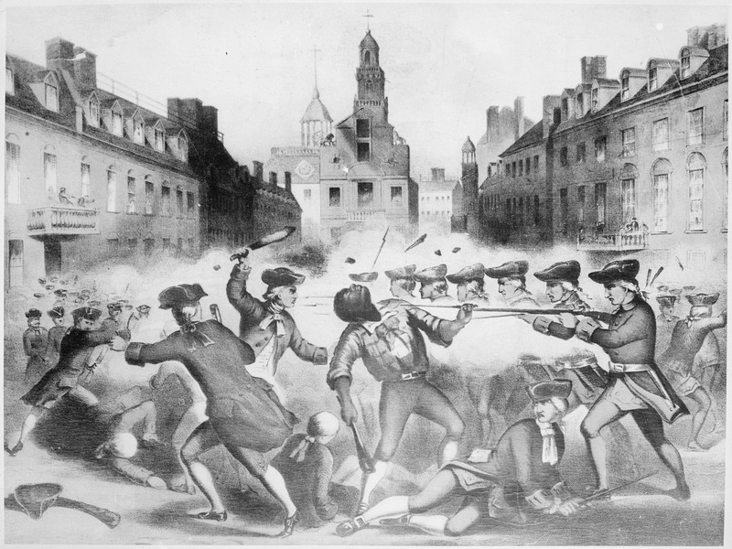
chromolithograph by John H. Bufford based on a drawing by William L. Champney (1856),

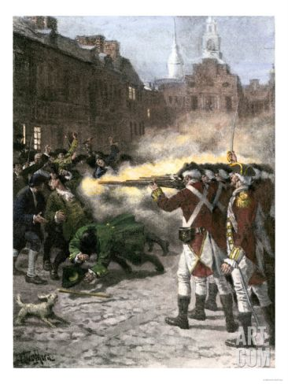
poster print from art.com (no info provided about source - assuming 20th c. interpretation)

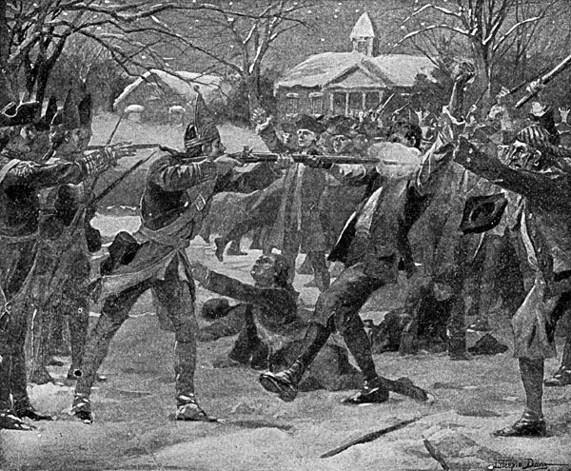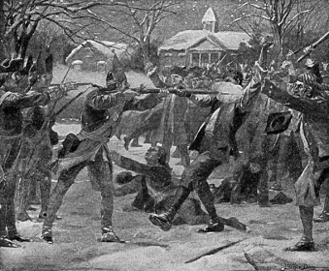
Artist Unknown (image reversed)

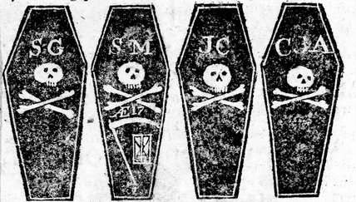
Accounts of the five victims of March 5 from the Boston Gazette, and Country Journal, March 12, 1770, Library of Congress.

Historical Record/Material about incident

Captain Preston's account of the Boston Massacre March 5 1770

It is [a] matter of too great notoriety to need any proofs that the arrival of his Majesty's troops in Boston was extremely obnoxious to its inhabitants. They have ever used all means in their power to weaken the regiments, and to bring them into contempt by promoting and aiding desertions, and with impunity, even where there has been the clearest evidence of the fact, and by grossly and falsely propagating untruths concerning them. On the arrival of the 64th and 65th their ardour seemingly began to abate; it being too expensive to buy off so many, and attempts of that kind rendered too dangerous from the numbers
And has ever since their departure been breaking out with greater violence after their embarkation. One of their justices, most thoroughly acquainted with the people and their intentions, on the trial of a man of the 14th Regiment, openly and publicly in the hearing of great numbers of people and from the seat of justice, declared "that the soldiers must now take care of themselves, nor trust too much to their arms, for they were but a handful; that the inhabitants carried weapons concealed under their clothes, and would destroy them in a moment, if they pleased". This, considering the malicious temper of the people, was an alarming circumstance to the soldiery. Since which several disputes have happened between the townspeople and the soldiers of both regiments, the former being encouraged thereto by the countenance of even some of the magistrates, and by the protection of all the party against government. In general such disputes have been kept too secret from the offi- cers. On the 2d instant two of the 29th going through one Gray's ropewalk, the rope-makers insultingly asked them if they would empty a vault. This unfortunately had the desired effect by provoking the soldiers, and from words they went to blows. Both parties suffered in this afftay, and finally the soldiers retired to their quarters. The officers, on the first knowledge of this transaction, took every precaution in their power to prevent any ill consequence. Notwithstanding which, single quarrels could not be prevented, the inhabitants constantly provoking and abusing the soldiery. The insolence as well as utter hatred of the inhabitants to the troops increased daily, insomuch that Monday and Tuesday, the 5th and 6th instant, were privately agreed on for a general engagement, in consequence of which several of the militia came from the country armed to join their friends, menacing to destroy any who should oppose them. This plan has since been discovered.
On Monday night about 8 o'clock two soldiers were attacked and beat. But the party of the townspeople in order to carry matters to the utmost length, broke into two meeting houses and rang the alarm bells, which I supposed was for fire as usual, but was soon undeceived. About 9 some of the guard came to and informed me the town inhabitants were assembling to attack the troops, and that the bells were ringing as the signal for that purpose and not for fire, and the beacon intended to be fired to bring in the distant people of the country. This, as I was captain of the day, occasioned my repairing immediately to the main guard. In my way there I saw the people in great commotion, and heard them use the most cruel and horrid threats against the troops. In a few minutes after I reached the guard, about 100 people passed it and went towards the custom house where the king's money is lodged. They immediately surrounded the sentry posted there, and with clubs and other weapons threatened to execute their vengeance on him. I was soon informed by a townsman their intention was to carry off the soldier from his post and probably murder him. On which I desired him to return for further intelligence, and he soon came back and assured me he heard the mobb declare they would murder him. This I feared might be a prelude to their plundering the king's chest. I immediately sent a non-commissioned officer and 12 men to protect both the sentry and the king's money, and very soon followed myself to prevent, if possible, all disorder, fearing lest the officer and soldiers, by the insults and provocations of the rioters, should be thrown off their guard and commit some rash act. They soon rushed through the people, and by charging their bayonets in half-circles, kept them at a little distance. Nay, so far was I from intending the death of any person that I suffered the troops to go to the spot where the unhappy affair took place without any loading in their pieces; nor did I ever give orders for loading them. This remiss conduct in me perhaps merits censure; yet it is evidence, resulting from the nature of things, which is the best and surest that can be offered, that my intention was not to act offensively, but the contrary part, and that not without compulsion. The mob still increased and were more outrageous, striking their clubs or bludgeons one against another, and calling out, come on you rascals, you bloody backs, you lobster scoundrels, fire if you dare, G-d damn you, fire and be damned, we know you dare not, and much more such language was used. At this time I was between the soldiers and the mob, parleying with, and endeavouring all in my power to persuade them to retire peaceably, but to no purpose. They advanced to the points of the bayonets, struck some of them and even the muzzles of the pieces, and seemed to be endeavouring to close with the soldiers. On which some well behaved persons asked me if the guns were charged. I replied yes. They then asked me if I intended to order the men to fire. I answered no, by no means, observing to them that I was advanced before the muzzles of the men's pieces, and must fall a sacrifice if they fired; that the soldiers were upon the half cock and charged bayonets, and my giving the word fire under those circumstances would prove me to be no officer. While I was thus speaking, one of the soldiers having received a severe blow with a stick, stepped a little on one side and instantly fired, on which turning to and asking him why he fired without orders, I was struck with a club on my arm, which for some time deprived me of the use of it, which blow had it been placed on my head, most probably would have destroyed me.
On this a general attack was made on the men by a great number of heavy clubs and snowballs being thrown at them, by which all our lives were in imminent danger, some persons at the same time from behind calling out, damn your bloods-why don't you fire. Instantly three or four of the soldiers fired, one after another, and directly after three more in the same confusion and hurry. The mob then ran away, except three unhappy men who instantly expired, in which number was Mr. Gray at whose rope-walk the prior quarrels took place; one more is since dead, three others are dangerously, and four slightly wounded. The whole of this melancholy affair was transacted in almost 20 minutes. On my asking the soldiers why they fired without orders, they said they heard the word fire and supposed it came from me. This might be the case as many of the mob called out fire, fire, but I assured the men that I gave no such order; that my words were, don't fire, stop your firing. In short, it was scarcely possible for the soldiers to know who said fire, or don't fire, or stop your firing. On the people's assembling again to take away the dead bodies, the soldiers supposing them coming to attack them, were making ready to fire again, which I prevented by striking up their firelocks with my hand. Immediately after a townsman came and told me that 4 or 5000 people were assembled in the next street, and had sworn to take my life with every man's with me. On which I judged it unsafe to remain there any longer, and therefore sent the party and sentry to the main guard, where the street is narrow and short, there telling them off into street firings, divided and planted them at each end of the street to secure their rear, momently expecting an attack, as there was a constant cry of the inhabitants to arms, to arms, turn out with your guns; and the town drums beating to arms, I ordered my drums to beat to arms, and being soon after joined by the different companies of the 29th regiment, I formed them as the guard into street firings. The 14th regiment also got under arms but remained at their barracks. I immediately sent a sergeant with a party to Colonel Dalrymple, the commanding officer, to acquaint him with every particular. Several officers going to join their regiment were knocked down by the mob, one very much wounded and his sword taken from him. The lieutenant-governor and Colonel Carr soon after met at the head of the 29th regiment and agreed that the regiment should retire to their barracks, and the people to their houses, but I kept the picket to strengthen the guard. It was with great difficulty that the lieutenant-governor prevailed on the people to be quiet and retire. At last they all went off, excepting about a hundred.
A Council was immediately called, on the breaking up of which three justices met and issued a warrant to apprehend me and eight soldiers. On hearing of this procedure I instantly went to the sheriff and surrendered myself, though for the space of 4 hours I had it in my power to have made my escape, which I most undoubtedly should have attempted and could easily executed, had I been the least conscious of any guilt. On the examination before the justices, two witnesses swore that I gave the men orders to fire. The one testified he was within two feet of me; the other that I swore at the men for not firing at the first word. Others swore they heard me use the word"fire," but whether do or do not fire, they could not say; others that they heard the word fire, but could not say if it came from me. The next day they got 5 or 6 more to swear I gave the word to fire. So bitter and inveterate are many of the malcontents here that they are industriously using every method to fish out evidence to prove it was a concerted scheme to murder the inhabitants. Others are infusing the utmost malice and revenge into the minds of the people who are to be my jurors by false publications, votes of towns, and all other artifices. That so from a settled rancour against the officers and troops in general, the suddenness of my trial after the affair while the people's minds are all greatly inflamed, I am, though perfectly innocent, under most unhappy circumstances, having nothing in reason to expect but the loss of life in a very ignominous manner, without the interposition of his Majesty's royal goodness.

THE HORRID MASSACRE IN BOSTON, PERPETRATED IN THE EVENING OF THE FIFTH DAY OF MARCH, 1770, BY SOLDIERS OF THE TWENTY-NINTH REGIMENT WHICH WITH THE FOURTEENTH REGIMENT WERE THEN QUARTERED THERE; WITH SOME OBSERVATIONS ON THE STATE OF THINGS PRIOR TO THAT CATASTROPHE
It may be a proper introduction to this narrative, briefly to represent the state of things for some time previous to the said Massacre; and this seems necessary in order to the forming a just idea of the causes of it.
At the end of the late [French and Indian] war, in which this province bore so distinguished a part, a happy union subsisted between Great Britain and the colonies. This was unfortunately interrupted by the Stamp Act; but it was in some measure restored by the repeal of it. It was again interrupted by other acts of parliament for taxing America; and by the appointment of a Board of Commissioners, in pursuance of an act, which by the face of it was made for the relief and encouragement of commerce, but which in its operation, it was apprehended, would have, and it has in fact had, a contrary effect. By the said act the said Commissioners were "to be resident in some convenient part of his Majesty's dominions in America." This must be understood to be in some part convenient for the whole. But it does not appear that, in fixing the place of their residence, the convenience of the whole was at all consulted, for Boston, being very far from the centre of the colonies, could not be the place most convenient for the whole. Judging by the act, it may seem this town was intended to be favored, by the Commissioners being appointed to reside here; and that the consequence of that residence would be the relief and encouragement of commerce; but the reverse has been the constant and uniform effect of it; so that the commerce of the town, from the embarrassments in which it has been lately involved, is greatly reduced.
The residence of the Commissioners here has been detrimental, not only to the commerce, but to the political interests of the town and province; and not only so, but we can trace from it the causes of the late horrid massacre. Soon after their arrival here in November, 1767, instead of confining themselves to the proper business of their office, they became partizans of Governor Bernard in his political schemes; and had the weakness and temerity to infringe upon one of the most essential rights of the house of commons of this province-that of giving their votes with freedom, and not being accountable therefor but to their constituents. One of the members of that house, Capt. Timothy Folgier, having voted in some affair contrary to the mind of the said Commissioners, was for so doing dismissed from the office he held under them.
These proceedings of theirs, the difficulty of access to them on office-business, and a supercilious behavior, rendered them disgustful to people in general, who in consequence thereof treated them with neglect. This probably stimulated them to resent it; and to make their resentment felt, they and their coadjutor, Governor Bernard, made such representations to his Majesty's ministers as they thought best calculated to bring the displeasure of the nation upon the town and province; and in order that those representations might have the more weight, they are said to have contrived and executed plans for exciting disturbances and tumults, which otherwise would probably never have existed; and, when excited, to have transmitted to the ministry the most exaggerated accounts of them.
Unfortunately for us, they have been too successful in their said representations, which, in conjunction with Governor Bernard's, have occasioned his Majesty's faithful subjects of this town and province to be treated as enemies and rebels, by an invasion of the town by sea and land; to which the approaches were made with all the circumspection usual where a vigorous opposition is expected. While the town was surrounded by a considerable number of his Majesty's ships of war, two regiments landed and took possession of it; and to support these, two other regiments arrived some time after from Ireland; one of which landed at Castle Island, and the other in the town.
Thus were we, in aggravation of our other embarrassments, embarrassed with troops, forced upon us contrary to our inclination-contrary to the spirit of Magna Charta-contrary to the very letter of the Bill of Rights, in which it is declared, that the raising or keeping a standing army within the kingdom in time of peace, unless it be with the consent of parliament, is against law, and without the desire of the civil magistrates, to aid whom was the pretence for sending the troops hither; who were quartered in the town in direct violation of an act of parliament for quartering troops in America; and all this in consequence of the representations of the said Commissioners and the said Governor, as appears by their memorials and letters lately published.
As they were the procuring cause of troops being sent hither, they must therefore be the remote and a blameable cause of all the disturbances and bloodshed that have taken place in consequence of that measure.
We shall next attend to the conduct of the troops, and to some circumstances relative to them. Governor Bernard without consulting the Council, having given up the State House to the troops at their landing, they took possession of the chambers, where the representatives of the province and the courts of law held their meetings; and (except the council-chamber) of all other parts of that house; in which they continued a considerable time, to the great annoyance of those courts while they sat, and of the merchants and gentlemen of the town, who had always made the lower floor of it their exchange. They [the merchants] had a right so to do, as the property of it was in the town; but they were deprived of that right by mere power. The said Governor soon after, by every stratagem and by every method but a forcibly entry, endeavored to get possession of the manufactory-house, to make a barrack of it for the troops; and for that purpose caused it to be besieged by the troops, and the people in it to be used very cruelly;
The General Court, at the first session after the arrival of the troops, viewed it in this light, and applied to Governor Bernard to cause such a nuisance to be removed; but to no purpose. [Text missing]....the challenging the inhabitants by sentinels posted in all parts of the town before the lodgings of officers, which (for about six months, while it lasted), occasioned many quarrels and uneasiness.
Capt. Wilson, of the 59th, exciting the negroes of the town to take away their masters' lives and property, and repair to the army for protection, which was fully proved against him. The attack of a party of soldiers on some of the magistrates of the town-the repeated rescues of soldiers from peace officers-the firing of a loaded musket in a public street, to the endangering a great number of peaceable inhabitants-the frequent wounding of persons by their bayonets and cutlasses, and the numerous instances of bad behavior in the soldiery, made us early sensible that the troops were not sent here for any benefit to the town or province, and that we had no good to expect from such conservators of the peace.
It was not expected, however, that such an outrage and massacre, as happened here on the evening of the fifth instant, would have been perpetrated. There were then killed and wounded, by a discharge of musketry, eleven of his Majesty's subjects, viz.:
- Mr. Samuel Gray, killed on the spot by a ball entering his head.
- Crispus Attucks, a mulatto, killed on the spot, two balls entering his breast.
- Mr. James Caldwell, killed on the spot, by two balls entering his back.
- Mr. Samuel Maverick, a youth of seventeen years of age, mortally wounded; he died the next morning.
- Mr. Patrick Carr mortally wounded; he died the 14th instant.
- Christopher Monk and John Clark, youths about seventeen years of age, dangerously wounded. It is apprehended they will die.
- Mr. Edward Payne, merchant, standing at his door; wounded.
- Messrs. John Green, Robert Patterson, and David Parker; all dangerously wounded.
The actors in this dreadful tragedy were a party of soldiers commanded by Capt. Preston of the 29th regiment. This party, including the Captain, consisted of eight, who are all committed to jail.
There are depositions in this affair which mention, that several guns were fired at the same time from the Custom-house; before which this shocking scene was exhibited. Into this matter inquisition is now making. In the meantime it may be proper to insert here the substance of some of those depositions.
Benjamin Frizell, on the evening of the 5th of March, having taken his station near the west corner of the Custom-house in King street, before and at the time of the soldiers firing their guns, declares (among other things) that the first discharge was only of one gun, the next of two guns, upon which he the deponent thinks he saw a man stumble; the third discharge was of three guns, upon which he thinks he saw two men fall; and immediately after were discharged five guns, two of which were by soldiers on his right hand; the other three, as appeared to the deponent, were discharged from the balcony, or the chamber window of the Custom-house, the flashes appearing on the left hand, and higher than the right hand flashes appeared to be, and of which the deponent was very sensible, although his eyes were much turned to the soldiers, who were all on his right hand.
What gave occasion to the melancholy event of that evening seems to have been this. A difference having happened near Mr. Grays ropewalk, between a soldier and a man belonging to it, the soldier challenged the ropemakers to a boxing match. The challenge was accepted by one of them, and the soldier worsted. He ran to the barrack in the neighborhood, and returned with several of his companions. The fray was renewed, and the soldiers were driven off. They soon returned with recruits and were again worsted. This happened several times, till at length a considerable body of soldiers was collected, and they also were driven off, the ropemakers having been joined by their brethren of the contiguous ropewalks. By this time Mr. Gray being alarmed interposed, and with the assistance of some gentlemen prevented any further disturbance. To satisfy the soldiers and punish the man who had been the occasion of the first difference, and as an example to the rest, he turned him out of his service; and waited on Col. Dalrymple, the commanding officer of the troops, and with him concerted measures for preventing further mischief. Though this affair ended thus, it made a strong impression on the minds of the soldiers in general, who thought the honor of the regiment concerned to revenge those repeated repulses. For this purpose they seem to have formed a combination to commit some outrage upon the inhabitants of the town indiscriminately; and this was to be done on the evening of the 5th instant or soon after; as appears by the depositions of the following persons, viz.:
William Newhall declares, that on Thursday night the 1st of March instant, he met four soldiers of the 29th regiment, and that he heard them say, "there were a great many that would eat their dinners on Monday next, that should not eat any on Tuesday."
Daniel Calfe declares, that on Saturday evening the 3d of March, a camp-woman, wife to James McDeed, a grenadier of the 29th, came into his father's shop, and the people talking about the affrays at the ropewalks, and blaming the soldiers for the part they had acted in it, the woman said, "the soldiers were in the right;" adding, "that before Tuesday or Wednesday night they would wet their swords or bayonets in New England people's blood."
Samuel Drowne declares that, about nine o'clock of the evening of the fifth of March current, standing at his own door in Cornhill, he saw about fourteen or fifteen soldiers of the 29th regiment, who came from Murray's barracks, armed with naked cutlasses, swords, &c., and came upon the inhabitants of the town, then standing or walking in Coruhffl, and abused some, and violently assaulted others as they met them; most of whom were without so much as a stick in their hand to defend themselves, as he very clearly could discern, it being moonlight, and himself being one of the assaulted persons. All or most of the said soldiers he saw go into King street (some of them through Royal Exchange lane), and there followed them, and soon discovered them to be quarrelling and fighting with the people whom they saw there, which he thinks were not more than a dozen, when the soldiers came first, armed as aforesaid. Of those dozen people, the most of them were gentlemen, standing together a little below the Town House, upon the Exchange. At the appearance of those soldiers so armed, the most of the twelve persons went off, some of them being first assaulted.
The violent proceedings of this party, and their going into King street, "quarrelling and fighting with the people whom they saw there" (mentioned in Mr. Drowne's deposition), was immediately introductory to the grand catastrophe.
These assailants, who issued from Murray's barracks (so called), after attacking and wounding divers persons in Cornhill, as abovementioned, being armed, proceeded (most of them) up the Royal Exchange lane into King street; where, making a short stop, and after assaulting and driving away the few they met there, they brandished their arms and cried out, "where are the boogers! where are the cowards!" At this time there were very few persons in the street beside themselves. This party in proceeding from Exchange lane into King street, must pass the sentry posted at the westerly corner of the Custom House, which butts on that lane and fronts on that street. This is needful to be mentioned, as near that spot and in that street the bloody tragedy was acted, and the street actors in it were stationed: their station being but a few feet from the front side of the said Custom House. The outrageous behavior and the threats of the said party occasioned the ringing of the meeting-house bell near the head of King street, which bell ringing quick, as for fire, it presently brought out a number of inhabitants, who being soon sensible of the occasion of it, were naturally led to King street, where the said party had made a stop but a little while before, and where their stopping had drawn together a number of boys, round the sentry at the Custom House. whether the boys mistook the sentry for one of the said party, and thence took occasion to differ with him, or whether he first affronted them, which is affirmed in several depositions,-however that may be, there was much foul language between them, and some of them, in consequence of his pushing at them with his bayonet, threw snowballs at him, which occasioned him to knock hastily at the door of the Custom House. From hence two persons thereupon proceeded immediately to the main-guard, which was posted opposite to the State House, at a small distance, near the head of the said street. The officer on guard was Capt. Preston, who with seven or eight soldiers, with fire-arms and charged bayonets, issued from the guardhouse, and in great haste posted himself and his soldiers in front of the Custom House, near the corner aforesaid. In passing to this station the soldiers pushed several persons with their bayonets, driving through the people in so rough a manner that it appeared they intended to create a disturbance. This occasioned some snowballs to be thrown at them which seems to have been the only provocation that was given. Mr. Knox (between whom and Capt. Preston there was some conversation on the spot) declares, that while he was talking with Capt. Preston, the soldiers of his detachment had attacked the people with their bayonets and that there was not the least provocation given to Capt. Preston of his party; the backs of the people being toward them when the people were attacked. He also declares, that Capt. Preston seemed to be in great haste and much agitated, and that, according to his opinion, there were not then present in King street above seventy or eighty persons at the extent.
The said party was formed into a half circle; and within a short time after they had been posted at the Custom House, began to fire upon the people.
Captain Preston is said to have ordered them to fire, and to have repeated that order. One gun was fired first; then others in succession and with deliberation, till ten or a dozen guns were fired; or till that number of discharges were made from the guns that were fired. By which means eleven persons were killed and wounded, as above represented.

Deposition of Theodore Bliss
At home. I heard the Bells for fire.t:3 Went out. Came to the Town House. The People told me there was going to be a Rumpus with the Soldiers. Went to the Custom house. Saw Capt. Preston there with the Soldiers. Asked him if they were loaded. He said yes. If with Ball. He said nothing. I saw the People throw Snow Balls at the Soldiers and saw a Stick about 3 feet long strike a Soldier upon the right. He sallied and then fired. A little time a second. Then the otherl s l fast after one another.
One or two Snow balls hit the Soldier, the stick struck, before firing. I know not whether he sallied on account of the Stick or step'd back to make ready. I did not hear any Order given by the Capt. to fire. I stood so near him I think I must have heard him if he had given an order to fire before the first firing. I never knew Capt. Preston before. I can't say whether he had a Surtout on, he was dressed in red. I know him to be the Man I took to be the Officer.
The Man that fired first stood next to the Exchange lane. I saw none of the People press upon the Soldiers before the first Gun fired. I did after. I aimed a blow at him myself but did not strike him. I am sure the Captain stood before the Men when the first Gun was fired. I had no apprehension the Capt. did give order to fire when the first Gun was fired. I thought, after the first Gun, the Capt. did order the Men to fire but do not certainly know. I heard the word fire several times but know not whether it came from the Captain, the Soldiers or People. Two of the People struck at the Soldiers after the first Gun. I dont know if they hit 'em. There were about 100 people in the Street. The muzzles of the Guns were behind him. After the first Gun the Captain went quite to the left and I to the right.
______________________________________________________________________

